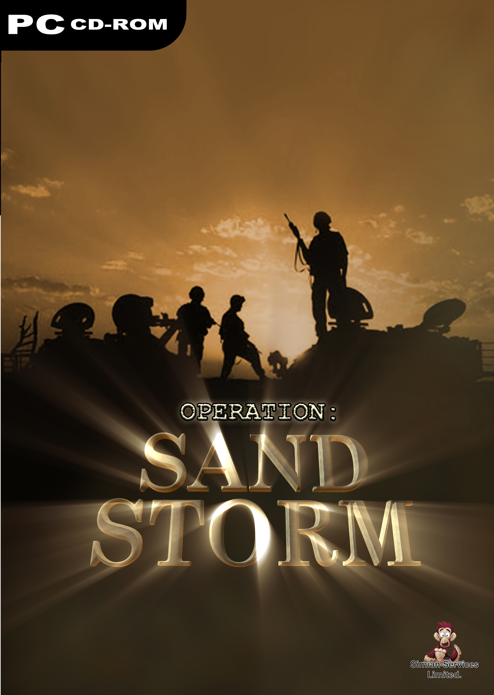

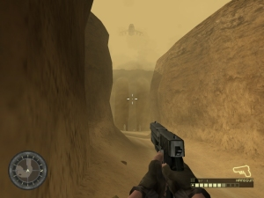 | 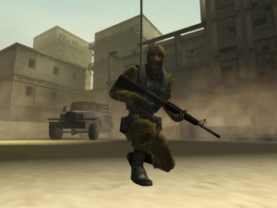

Installing the Game
1: Insert the game disc. If the disc does not autorun then double click on the setup.exe icon in the root directory of the disc.
2: Simply follow the on screen prompts to select your language and your installation directory. If your current version of direct X needs upgrading then you may wish to install it.

If you ever wish to remove the game double click on the uninstall icon that can found in the directory that you installed the game to and also in the windows start menu.

Running the Game
Once the game has installed, double click on the game icon to run the game. The first time you run the title a configuration window will open. This will let you select the display resolution as well as a few other graphical options.

If you ever wish to change these settings simply run the configuration.exe again.

Main Menu
Start Game: Selecting this option will start a new game. At this point you may select a difficulty level.

Load Game: Choosing this option will let you load a previously saved game. The game prompts you to save after each mission.

Options: Choosing this option will allow you to set up your controls if you wish and alter the game sound and music volume.

Controls
Movement
E Move Forward
D Move Backward
S Sidestep Left
F Sidestep Right
C Crouch

Actions
Left Mouse Button Fire
Right Mouse Button Zoom
Q Next Weapon
W Previous Weapon
R Reload
SPACE Activate/Pick Up Key
ESC Pause/ menu

